HEAT
Conduction, Convention & Radiation

Name: Class: Date:

INFORMATION - HEAT TRANSFERS

Heat and temperature are important concepts in all areas of science and in students’ day-to-day lives. People deal with heat and temperature in their everyday experiences, yet many people hold serious misconceptions about them.
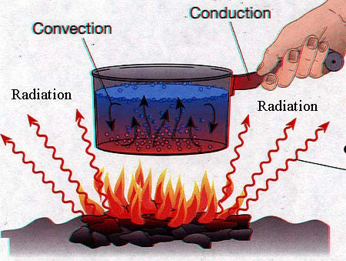
All matter is made up of particles. The particles of any particular object will be moving because of the temperature of the object is. The hotter the object the faster and more violently the particles in it are moving. Thermal energy (NOT heat energy) is the energy possessed by an object because of it’s temperature. Heat is thermal energy that is in transit. Heat moves (transfers) from warmer objects to cooler objects.
Heat is the energy transferred from one object to another because of a difference in their temperatures
But how exactly is heat transferred from warmer matter to cooler matter?
Heat is transferred in three distinct ways which is by conduction, convection or radiation; or all of which may be occurring at any given time.

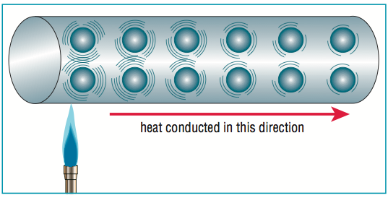
Conduction is the transfer of the heat through a solid object. In order for the heat to be conducted, there should be physical contact between particles and some temperature difference. When one part of an object is heated, the molecules within it vibrate against one another; begin to move faster and more vigorously, when these molecules hit other molecules within the object they cause heat to be transferred through the entire object. Substances that conduct heat readily are called conductors, while substances that don't conduct heat readily are called insulators. Metal (e.g. copper, platinum, gold iron, etc) is a good conductor of thermal energy, aluminum is a good insulator. Wood falls somewhere in between. Conduction is greater in solids, where molecules are in close and constant contact. As density decreases so does conduction. Therefore, fluids (and especially gases) are less conductive due to the large distance between particles in a gas – there are fewer collisions between the particles means less conduction. Generally liquids and gases transfer heat using convection not conduction.
Convection is the transfer of heat energy caused by the movement of a liquid or gas (such as air). Heat is transferred when a heated liquid or gas moves from place to another, carrying its heat with it. Unlike conduction where the particles remain in place but pass on their vibrational energy as heat, in convection the particles move from one place to another, carrying the heat with them. The rate of heat flow will depend on the temperature of the moving gas or liquid and on its rate of flow.
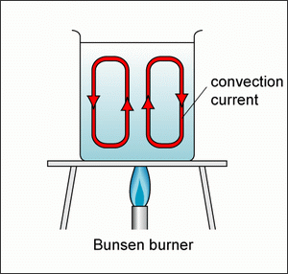
Convection currents due to warmer air rising and cooler air falling is a common mechanism by which thermal energy is transferred. When air is heated, it expands, and therefore becomes less dense, so it rises. The rising warm air displaces cooler air, which sinks. When the motion is constant, it's called a convective loop or convection current. Oil heaters and air conditioners cause convective loops by heating or cooling (respectively) the air closest to them.
Radiation is a method of heat transfer which does not rely upon any contact between the heat source and the heated object. For example, we feel heat from the Sun or a fire even though we are not touching them. Radiation can travel through empty space and transparent things such as air and glass, but it cannot travel through opaque objects like surfaces and walls.
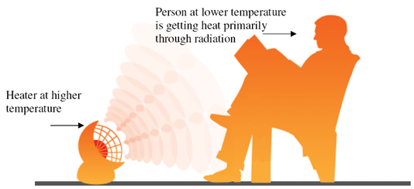
Radiation is the transfer of energy by infrared waves (a type of electromagnetic wave, like visible light). All objects possess thermal energy and therefore emit some infrared waves. Hotter objects are more thermal energy than cooler ones and emit more radiant energy as infrared waves. The concept of heat transfer by radiation can be understood using experiences familiar to us in everyday life: the warmth of the Sun, a campfire, or an open oven door.
In most situations, more than one method of heat transfer takes place. For example, in the boiling water and pasta convection example above, water becomes warmer due to the transfer of heat from the stove burner to the pot and then from the pot to the water (conduction). Developing the idea that heat transfers occur in a variety of ways should be emphasized rather than defining the differences between conduction, convection, and radiation.
It should be recognized that heat transfers can be used to explain everyday phenomenon. However this can be a very challenging and abstract idea for many of us. Some people may continue to hold on to their belief that heat moves from a colder object to a warmer object or that both “heat” and “cold” are transferred at the same time. You feel colder not because you have gotten more cold, but because you have lost some thermal energy by conduction, convection, or radiation.
ACTIVITY-1 - Answer the following questions based on the reading passage

- What is heat?

- Define conduction

- A) You are outside on a cold day and sit down on a metal bench. What does it feel like and why?

B) You get up from the bench after sitting for a while. You place your hand where you have just been sitting. Predict what it would feel like and explain your reasoning.

- A person touches a large chunk of ice with their hand and remarks, “This is making me cold.” Explain what this person is feeling. Is the ice transferring “cold” to the person? Is there a heat transfer occurring? Explain.

- Nate was stirring hot soup on the stove. Why should he use a wooden spoon instead of a metal spoon?

- Amber bought a coat with goose down insulation to keep her warm in the winter in Utah. Explain why a coat filled with goose down is a good choice to keep her warm.

- Define convection

- Define Radiation

2. Decide whether the following statements are True or False. Circle the correct answer.

- Heat, energy and temperature are all different names for the same thing. | TRUE OF FALSE
- Everything has some thermal energy. | TRUE OF FALSE
- Heat energy is another way of saying thermal energy. | TRUE OF FALSE
- Thermal Energy is stored as conduction, convection, and radiation. | TRUE OF FALSE
- Heat travels from warmer to colder places. | TRUE OF FALSE
- Conduction of heat only occurs in liquids. | TRUE OF FALSE
- When an object is heated, the particles present move slower. | TRUE OF FALSE
- All materials conduct heat. | TRUE OF FALSE
- Materials containing air are usually good insulators. | TRUE OF FALSE
- Convection occurs in fluids due to movement of these fluids. | TRUE OF FALSE
- The Sun is a major source of infrared radiation. | TRUE OF FALSE
- Silver and shiny surface are good absorbers of heat radiation. | TRUE OF FALSE
- Heat transfer occurs only with solids. | TRUE OF FALSE
- Heat can occur as a result of physical and chemical changes. | TRUE OF FALSE
- Infrared rays travel at the speed of light. | TRUE OF FALSE
- Only objects that feel warm to the touch have heat energy. | TRUE OF FALSE

ACTIVITY-2 (Select the correct options in the following examples)

Which of the following is an example of heat conduction?
a) An air vent from a furnace sending hot air into the house.
b) A metal cup heating up when hot water is poured into it.
c) The sun melting the ice formed on a frosty lawn.
d) Cool air sinking to the ground on a cold night.

By what process does heat energy travel from the sun to the earth?
a) Heat is radiated through space.
b) Heat is conducted through air molecules.
c) Convection of heat through air currents.
d) Heat travels through the wind.

In a room in the wintertime, where would you find the warmest air?
a) near the ceiling b) near the floor
c) in the corners d) by a window

Which of the following is not a method of heat transfer?
a) Conduction b) Convection
c) Condensation d) Radiation

Heat transfer by conduction
a) is not possible from human beings to their environment.
b) does not occur from light bulbs − they are too bright.
c) None of the above.
d) requires some sort of material to facilitate the heat transfer.

Which of the following is the best conductor of heat?
a) air b) plastic
c) water d) aluminum

Which of the following is the worst conductor of heat in the group?
a) air b) plastic
c) a vacuum d) aluminum

The fact that, in general, liquids and gases expand when heated gives rise to
a) convection currents in fluids due to changing masses.
b) convection currents in fluids due to changing densities.
c) heat transfer by conduction.
d) convection currents in fluids due to constant temperatures.

In which of the following can convection currents be set up?
a) air b) a vacuum
c) plastic d) aluminum

The predominant method of heat transfer that causes a pot of water to boil is
a) conduction. b) convection.
c) radiation. d) boiling.

The process by which a pot of water on your electric stove starts to heat is
a) conduction. b) convection.
c) radiation. d) evaporation.

The method through which the entire pot of water boils on that hot stove is
a) conduction. b) convection.
c) radiation. d) evaporation.

This type of heat transfer can occur in a vacuum:
a) Conduction. b) Convection.
c) Radiation. d) Blackbody.

Heat transfer by radiation
a) is not possible from human beings to their environment.
b) does not occur from light bulbs − they are too bright.
c) does not require any material between the radiator and the object receiving the radiation.
d) none of the above.

Which one of the following statements concerning the transfer of heat is not correct?
a) Conduction and convection may take place in solids.
b) Convection may take place in liquids and gases.
c) Convection and radiation may take place in gases.
d) Radiation and conduction may take place in solids.
e) Conduction may take place in solids and liquids.

Which of the following methods of heat transfer involves the actual physical movement of high temperature molecules to regions of lower temperature?
a) condensation b) conduction
c) convection d) radiation

If one's hands are being warmed by holding them to one side of a flame, the dominate form of heat transfer is which of these processes?
a) conduction b) radiation
c) convection d) Vaporization

The transfer of energy by the movement of fluids or gases with
different temperatures is called
a) convection. b) conduction.
c) radiation. d) contact.

ACTIVITY-3
1 Select the correct mode of heat transfer for the following examples (Conduction, convection, or radiation)
The heat you feel from a fireplace
This type of heat transfer causes plates to move
Boiling water
Heat you feel from a hot stove
Frying a pancake
Fast particles colliding with slower particles
Air travels this way
Transfer through solids
Transfer through space
Moves as a wave
Moves as a current
Sun rays reaching earth
Occurs with fluids
A coil on an electric stove
This type of transfer is affected by color
You feel the steam rising from a cup of hot chocolate.
You burn your tongue drinking hot chocolate.
A spoon in the hot chocolate becomes warm
You are warmed standing in front of a fireplace
On a sunny day, the sand at the beach can get very hot, if you step on it you feel the heat
The side of the moon that faces the sun becomes extremely hot

2-Explain each of the following cases

- A saucepan might have a copper bottom but a plastic handle

- The smoke from a bonfire rises upwards

- Why air conditioners are never installed near the floor of the room

- Why newspaper wrapping keeps hot things hot eg fish and chips, and cold things cold eg ice cream

- If you put your hand above a burning match, your hand feels hot. However your hand does not feel particularly hot when it is underneath the burning match

Concept Map - Construct a concept map using the terms heat, conduction, convection, and radiation.
The main concept (heat) should be at the top. Place the other 3 terms in ovals and connect the ovals with lines on which linking words are placed. For each of the 3 terms, a further link to a brief description and some examples should be put in.

11

